PERSONAL INFORMATION | Cristian Fortuna
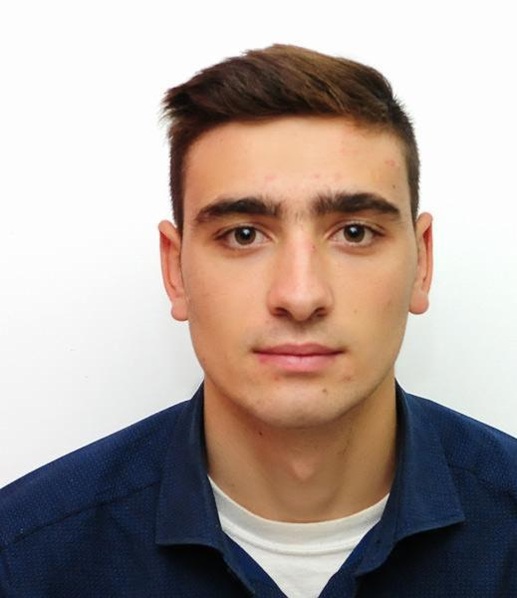 |   Canada, 5780 Hastings str. Burnaby, 28 flat

+12368186289

cristian.fortuna01@gmail.com

STUDIES APPLIED FOR | This Curriculum Vitae is issued for job offer

WORK EXPERIENCE

02/11/2018–present | Program manager on renewable sources of energy
02/11/2018–present | Agency for Efficient Energy, Chisinau (Moldova)
02/11/2018–present | work on oversee development of the situation in the field of energy efficiency and renewable energy sources, to ensure preparation and submission of summaries of programs, investment evaluation of projects in the field, the development projects of normative acts, as well as the development of an information database in its areas of activity.

28/05/2017—12/09/2017 | Hotel Front Desk Clerks
28/05/2017—12/09/2017 | Hilton Ocean City Oceanfront Suites(United States of America)
28/05/2017—12/09/2017 | My duties also may include room reservations and assignment, guest registration, cashier work, credit checks, key control as well as mail and message service.

26/05/2017–10/09/2017 | Mechanical engineering technician
26/05/2017–10/09/2017 | Harbor Marine Inc, Ocean City (United States of America)
26/05/2017–10/09/2017 | relations with suppliers, boat repair, electrical supply

EDUCATION AND TRAINING

01/09/2014–30/05/2018 | Electrical Engineering
01/09/2014–30/05/2018 | Technical University of Moldova, Chisinau (Moldova)
01/09/2014–30/05/2018 | knowledge of engineering

05/05/2013–26/05/2013 | Certificate in business and entreprenourship
05/05/2013–26/05/2013 | Organisatin for International Migration, Chisinau (Moldova)

PERSONAL SKILLS

Mother tongue(s) | Moldavian
Other language(s) | UNDERSTANDING |  | SPEAKING |  | WRITING
Other language(s) | Listening | Reading | Spoken interaction | Spoken production
English | B1 | B2 | B2 | C2 | B2
French | A1 | A2 | A1 | A2 | A1
Romanian | C1 | C1 | C2 | C2 | C2
Russian | C1 | B2 | C1 | C1 | C1
Levels: A1 and A2: Basic user - B1 and B2: Independent user - C1 and C2: Proficient user
Common European Framework of Reference for Languages

Communication skills | Good comunication skills gained through my experience as a shop worker, excelent contact skills with my co-workers at Agency for Eficient Energy where I have been worked as a volunteer

Digital skills | SELF-ASSESSMENT
Digital skills | Information processing | Communication | Content creation | Safety | Problem solving
 | Independent user | Independent user
 | Digital skills - Self-assessment grid

